
Artificial Intelligence Lab_CS-202L
UW-24-CS-BS-101
Registration NO:
Muhammad Talha_CS.3ndB
Lab Task # 07
UNIVERSITY OF WAH(UOW)

DEPARTMENT OF COMPUTER
SCIENCE

COURSE:

SUBMITTED TO:

Mr. Hasssan Shafaqat
SUBMITTED BY:

Task # 01
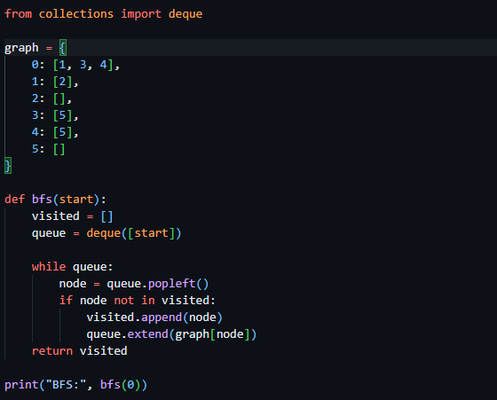
Output

Task # 02
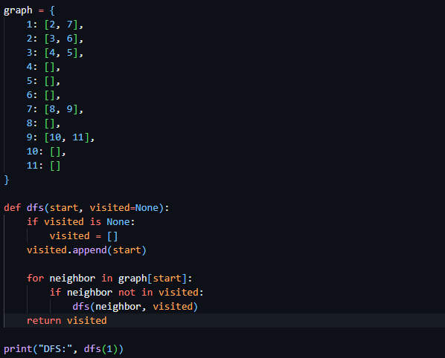
Output

